**EXPERIMENTAL ANALYSIS OF PERFORMANCE ,COMBUSTION AND EMISSION CHARACTERISTICS OF SINGLE CYLINDER DIESEL ENGINE USING BIODIESEL BLENDS (TURPENTINE OIL BLEND)**

Dr. A. Sangeet Sahaya Jeyangel*, Dhinesh babu R, Akilan S, HariVignesh NS, Niroshini K.

Department of automobile engineering, Madras institute of technology, chrompet, Chennai.

*A R T I C L E I N F O* A B S T R A C T

Main aim of our project is to study the influence of hydrogen induction on the performance, combustion and emission characteristics of a compression ignition engine fueled with Turpentine oil biodiesel. The Turpentine oil biodiesel was mixed with diesel in various proportions. Mainly the B20, B30, B40 and B50 blends were taken into account. The hydrogen gas was inducted at the rate of 2lpm, 4lpm and 6lpm.The test was conducted on a 5.2 kW four stroke, single cylinder diesel engine with compression ratio of 17.5:1. The results obtained are compared with neat diesel fuel at all the loads. The biodiesel blends show a significant reduction in the BTE when compared to the diesel fuel. The in cylinder pressure and the amount of heat released is also found to be lesser than diesel. But there is a reduction in the CO, HC and smoke emissions. But still the NOx emissions are higher than the diesel. The hydrogen induction at the rate of 6lpm showed better results than 2lpm and 4lpm.Hydrogen enrichment with B20 showed a substantial increase in BTE due to the superior combustion properties of the hydrogen gas. The in-cylinder pressure and heat release rate are also significantly improved. When analysing the emissions, NOx is very high for hydrogen induction. This is attributed to the high in cylinder temperature generated during the combustion of fuel.

Keywords:

Turpentine oil

Engine performance

Combustion

Emission

Cylinder pressure

Heat release rate

**INTRODUCTION**

**1.1 OVERVIEW**

Transportation has been an important aspect of human life from the old ages.

The modes of transport have been evolving and upgrading from horses and carts to hyperloops. Only after the invention of engines,the transportation became easier. The 2 and 4 stroke engines have made our trips effort less. Two wheelers and four wheelers have become more popular and user friendly among us. The usage of the vehicles is increasing day by day. Now, the fuels used for powering

these engines must be taken in account. There are numerous fuels used for this

purpose, which mostly fall under two categories, renewable and non-renewable resources. Both has its own advantages and disadvantages.

**1.2 RELATED STUDY**

**Fuels**

The evolution of fuels used in today’s automotive industry is very well known to everyone. In the pre-automotive ages, people used firewood as fuel. No automotive was invented till then of course. With this, they started using the coal present on the ground and when they used up all of it, miners started digging the ground for more coal. This was the revolutionary point where Thomas Newcomen invented a coal-burning steam engine to pump out water and allow miners to dig deeper. Further, James Watt made some improvements in the engine and made it fit for other uses as well. Most of us know that trains used to run on steam-powered engines and therefore, this is one of the largest used automotive power sources from the past. The next important fuel is the petrol or gasoline. It became a commonly used automotive fuel. In 1 876, Nicolaus Otto invented the petrol engine and its working cycle is named after him only. Another commonly used petroleum product as an automotive fuel is diesel. Developed in the 1890s, the diesel engines are still used to power many machines. It is the most commonly used automotive fuel used to power heavy vehicles like trucks and buses. These are the majorly used conventional fuels in Automobiles.

**3.ALTERNATE FUELS**

After analysing the pros and cons of using these fuels, many scientists have opted for the usage of various alternative sources of fuel for automobile. Alternative fuels are derived from sources other than petroleum. Most are produced domestically, reducing our dependence on imported oil, and some are derived from renewable sources. Often, they produce less pollution than gasoline or diesel. Alternative fuels include gaseous fuels such as hydrogen, natural gas, and propane; alcohols such as ethanol, methanol, and butanol; vegetable and waste-derived oils; and electricity. These fuels may be used in a dedicated system that burns a single fuel, or in a mixed system with other fuels including traditional gasoline or diesel, such as in hybrid-electric or flexible fuel vehicles.

**3.1 TURPENTINE OIL:**

Turpentine oil is used as medicine. In medicine, it is used in preparation that acts as a local stimulant, anesthetic, and antiseptic. It is used externally in ointments for neuralgia and myositis.

Turpentine oil works as a feedstock chemical in the manufacture of flavaring, pinenes, pine oil, polymer additives and fragrances. It is also used as a commercial source of fuel and as an alternative of fossil fuels in a broad range of applications such as furnaces, rocket fuels and industrial boilers. Turpentine oil has a low healing coefficient ranging between 16,000 & 18,000 Btu/lb as compared to other fossil fuels such as gasoline, diesel, butane and propane

**3.2 COMPOSITON :**

It contains

* 65% of rosin (solid residue)
* 18% of oil

**3.3 OIL YIELD :**

**Pine trees are hardy trees that tolerate at low temperatures, high altitudes, and acidic, sandy soil. Typically, pine trees reach full maturity in 25 to 30 years with some species of pine tree growing to be 150 feet tall. All pine trees begin as small seeds, growing to saplings and then to a mature trees.** The height of a mature tree can vary greatly depending on the species.**For example ,a dwarf mugo pine might only grow to be 4 feet tall ,But under the right conditions, a white pine can grow to be over 150 feet tall .** In pine trees, this age is considered “grown up” because this is when growth dramatically slows and its wood is harvested.

**3.4 PRODUCTION OF TURPENTINE OIL :**

Pines are naturally found almost exclusively in the Northern Hemisphere. They are found in much of North America, China, South-East Asia, Russia and Europe .Pine trees are the dominant plants which grow in many cold temperature and boreal forests. They are particularly successful in cold areas where broad-leaved plants are unable to survive such as the boreal forest and at high altitude. There is estimated to be around 250 species of pines throughout the world and It includes a total of 11 genera which include the spruces, cedars, firs, pines and more. According to the height, space between the tress it can be planted 620 or 435 trees per acer. In India pine trees are mostly cultivated in cold and hilly regions like Himachal Pradesh, Ooty , kodaikanal etc Pine species are also used widely for shelter and theinterlinked purposes of revegetation, soil stabilization, and soil conservation, as befits their tolerance of exposure and degraded soils in certain species. Most of the widely planted species of pines are used in some degree for one or more of these purposes, often with timber production as a major bonus. Ornamental and festive use is common, with P. sylvestris and P. virginiana being very widely grown for Christmas trees.

**PROPERTIES**

**4.1 : PROPERTIES OF TURPENTINE BIO DIESEL:**

**4.1.1 : KINEMATIC VISCOSITY:**

The kinematic viscosity of a fluid is the ratio of the viscosity of the fluid to the fluid's density. Mathematically, it is expressed as:

ν = μ / ρ

where *ν* is the kinematic viscosity, *μ* is the dynamic viscosity, and*ρ* is the density. The kinematic viscosity is an important fuel property which affects the atomization of a fuel upon injection into the combustion chamber. The values of diesel and turpentine oil bio diesel are very close, when compared to other bio diesels. Hence, as the viscosity is less, the fuel is atomized properly, resulting in a complete combustion and good engine performance.

**4.1.2 FLASH POINT:**

The flash point is the lowest temperature at which a volatile substance evaporates to form an ignitable mixture with air in the presence of an igneous source and continues burning after the trigger source is removed. Flash point is a significant property not for the operability of a diesel fuel, but for its storage and handling. Diesel fuels are classified as nonvolatile fuels, and their storage does not need specific precautions. Flash point is an excellent indication of diesel fuel contamination with more volatile products.

**4.1.3 DENSITY:**

The density of material shows the denseness of that material in a specific given area. A material’s density is defined as its mass per unit volume. Density is essentially a measurement of how tightly matter is packed together. It is a unique physical property for a particular object. The principle of density was discovered by the Greek scientist Archimedes. It is easy to calculate density if you know the formula and understand the related units The symbol ρ represents density or it can also be represented by the letter D.

**4.1.4 CALORIFIC VALUE:**

Calorific value is defined as the amount of heat energy released during complete combustion of a unit mass of a fuel. It is expressed in kJ/kg.

**4.3 PROPERTIES OF BIODIESEL BLENDS**

**4.3.1 DENSITY**



**Table 4.1**

**4.3.2 FLASH AND FIRE POINT**



**Table 4.2**

|  |  |  |  |  |  |
| --- | --- | --- | --- | --- | --- |
| **BLEND** | **DENSITY(kg/m³)** | **KINEMATIC VISCOSITY ( m²/s)** | **FLASH POINT (°c)** | **FIRE POINT (°c)** | **CALORIFIC VALUE (kJ/kg)** |
| DIESEL | 0.827 | 13.28 | 47 | 54 | 42500 |
| B20 | 0.831 | 14.567 | 49 | 55 | 42880 |
| B30 | 0.835 | 14.147 | 52 | 57 | 43070 |
| B40 | 0.839 | 13.360 | 55 | 60 | 43260 |
| B50 | 0.844 | 13.055 | 57 | 62 | 43450 |
| TURPENTINE | 0.845 | 10.870 | 53 | 58 | 44400 |

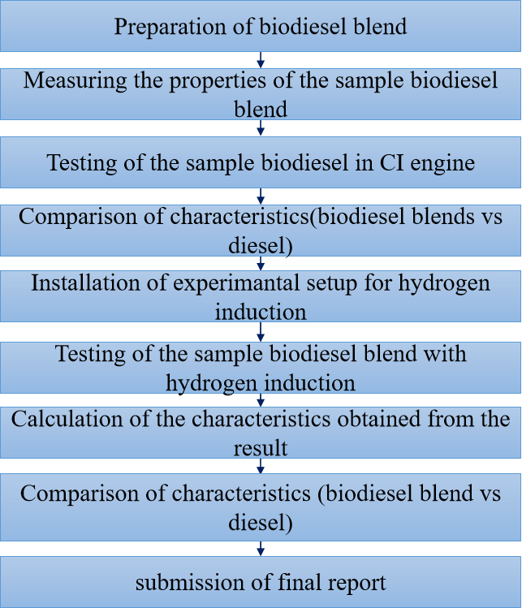**PROPERTIES OF FUEL**

**5.1 STEP 1 – COLLECTION OF PINE SAPS**

Turpentine were collected from the pine tree . pine trees are mostly seen in the hillstations . pine saps were collected by Drilling a hole into pine tree using a bit size recommended for your spile. Once your hole is started, insert the spile at a downward angle and gently tap the tapered end in with a hammer. If the sap is running, a drop will appear at the tip of the spile. Hang a covered collection bucket from the spile.  turpentine is obtained by the steam distillation of dead, shredded bits of pine wood, while gum turpentine results from the distillation of the exudate of the living pine tree obtained by tapping



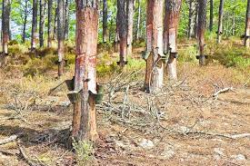

**STEP 2 - EXTRACTION OF RAW OIL:**

The collected oil was initially filtered and pre-treated for removal of suspended as well as unwanted/foreign particles. The collected saps are crushed using oil crusher to obtain raw oil.

**5.3 STEP 3 - PREPARATION OF BIODIESEL BLENDS:**

Biodiesel was blended in the ratio of 20%(D80T20),30%(D70T30), 40%(D60T40) , 50%(D50T50) with diesel and the engine test was carried out .

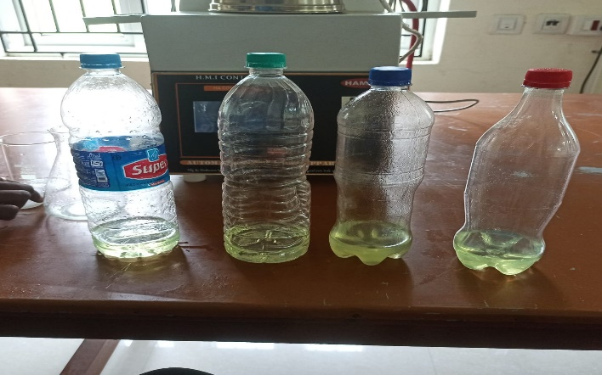

**Fig 5.4**

**SPECIFICATIONS**

**6.1 ENGINE DESCRIPTION:**

The setup consists of single cylinder, four stroke, Diesel engine connected to eddy current type dynamometer for loading. It is provided with necessary instruments for combustion pressure and crank‐angle measurements. These signals are interfaced to computer through engine indicator for Pθ−PV diagrams. Provision is also made for interfacing airflow, fuel flow, temperatures and load measurement. The setup has stand‐alone panel box consisting of air box, fuel tank, manometer, fuel measuring unit, transmitters for air and fuel flow measurements, process indicator and engine indicator. Rotameters are provided for cooling water and calorimeter water flow measurement. The setup enables study of engine performance for brake power, indicated power, frictional power, BMEP, IMEP, brake thermal efficiency, indicated thermal efficiency, Mechanical efficiency, volumetric efficiency, specific fuel consumption, A/F ratio and heat balance. LabVIEW based Engine Performance Analysis software package “Enginesoft” is provided for on line performance evaluation. A computerized Diesel injection pressure measurement is optionally provided. A computerized Diesel injection pressure measurement is optionally provided

**6.2 FEATURES:**

* 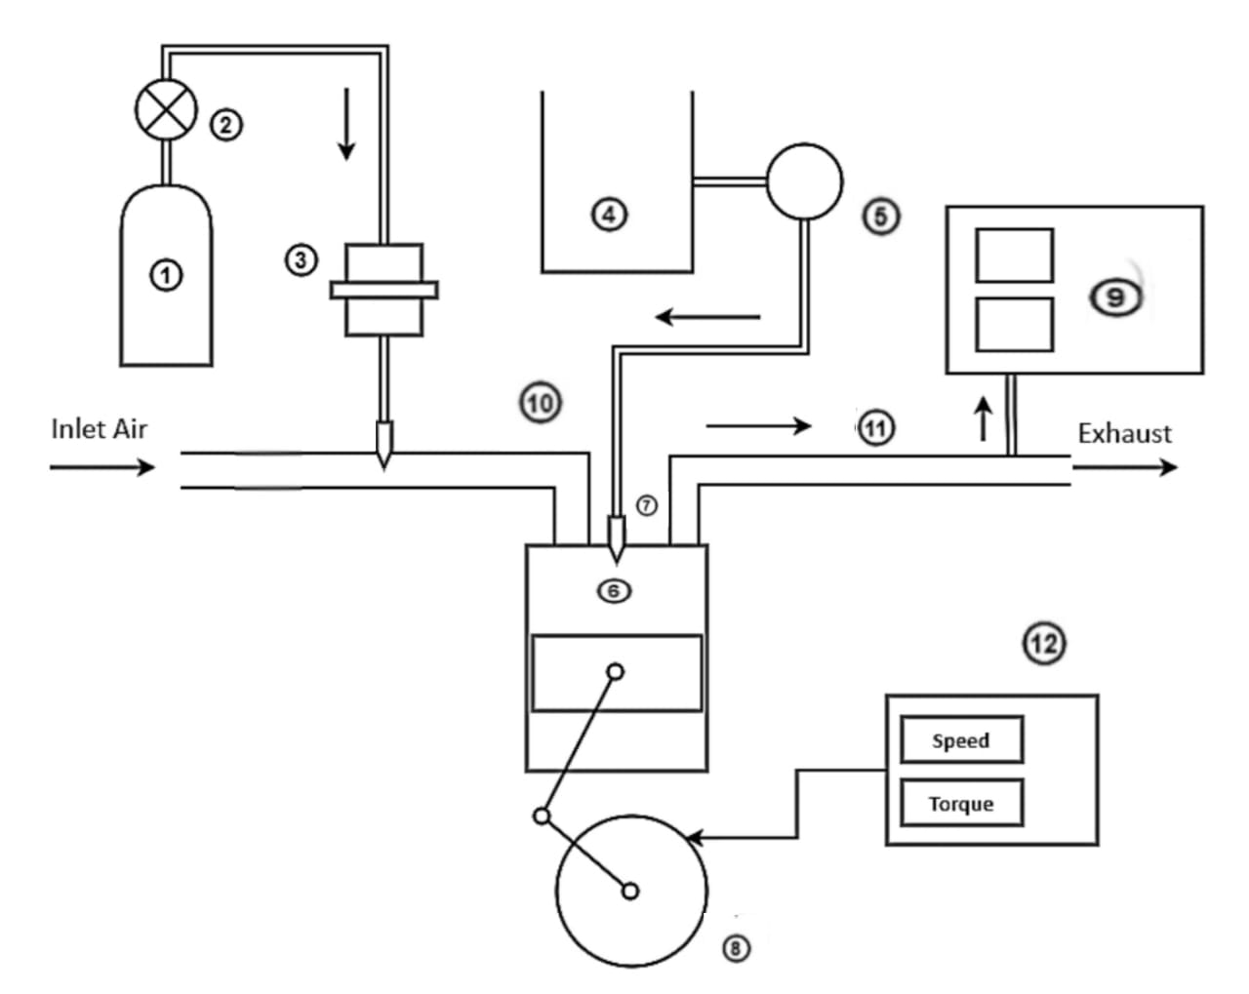Online measurements and performance analysis
* PΘ‐PV plots, performance plots and tabulated results
* Configurable graphs
* IP, IMEP, FP indication
* Combustion analysis

**6.3ENGINE LAYOUT:**

**① -** Hydrogen Storage Tank

**② -** Pressure Regulator

**③** **-** Flame Arrestor

**④** **-** biodiesel-Diesel blend tank

**⑤** **-** Fuel Pump

**⑥** **-** Diesel Engine

**⑦ -** Fuel Injector

**⑧ -** Crank Wheel

**⑨ -**  Exhaust Gas Analyzer

**⑩ -** Inlet Manifold

**⑪ -** Exhaust Manifold

**⑫ -** Dynamometer

**PERFORMANCE, COMBUSTION AND EMISSION CHARACTERISTICS**

**7.1 PERFORMANCE PARAMETERS:**

****7.1.1 BRAKE THERMAL EFFICIENCY:  *Fig 7.1***

The Brake Thermal Efficiency of various fuels namely neat diesel, biodiesel blends namely B20,B30,B40 and B50 brake power conditions are plotted as a graph and the results are analyzed. It is observed that brake thermal eiciencies of biodiesel blends decreases with increase in percentage of biodiesel because of poor volatilability and inferior combustion characteristics of the biodiesel.

**7.2 COMBUSTION PARAMETERS:**

**7.2.1 IN-CYLINDER PRESSURE:**



#### 

The cylinder pressure obtained using the pressure sensor at each crank angle and it is plotted as a graph. Pressure variations of neat diesel, biodiesel blends B20, B30,B40, B50 is seen in the above graph. We can see a drop in the peak pressure of the biodiesel blend B20 when compared to the neat diesel fuel. The reduced pressure produced by the biodiesel may be due to lower calorific value. This means lower heat releasing capacity. Also, there is improper combustion of fuel samples due to lower volatility and higher viscosity. The combined effect of all these conditions, leads to reduction in the peak pressure produced during combustion by the biodiesel than neat diesel fuel.`

**7.2.2 HEAT RELEASE RATE:**

The heat released by various fuels namely neat diesel, biodiesel blends B20, B30, B40, B50 at various loading conditions are plotted as a graph and the results are analysed. It is seen that a negative HRR value was obtained before starting the combustion. This is due to the evaporation of the liquid fuel accumulated during the ignition delay period and the heat absorption from the environment. The HRR value becomes positive when the combustion starts. The lesser HRR of the biodiesel B20 is mainly due to the lower calorific value of the biodiesel. Due to this, the amount of heat released on the combustion of this fuel also tends to be lesser.

**7.3 EMISSION PARAMETERS:**

**7.3.1 HYDROCARBON EMISSION:**

#### 

HC emission is mainly due to the unburnt hydrocarbon molecules. Variation of HC with operating load conditions for the neat diesel, B20, B30, B40, B50 is shown in the above graph. Compared to the biodiesel fuel, diesel gives lesser HC emissions due the presence of more oxygen in it. Presence of oxygen enhances the rate of combustion. Hence the emission of unburnt hydrocarbons is automatically reduced.

**7.3.2** **CARBON MONOXIDE EMISSIONS:**

Carbon monoxide is one of the compounds formed during the intermediate combustion stages of hydrocarbon fuels. As combustion proceeds to completion, oxidation of CO to CO2 occurs through recombination reactions between CO and the different oxidants. If these recombination reactions are incomplete due to lack of oxidants or due to low gas temperatures, CO will be left. Variation of CO emissions with operating load conditions for the neat diesel, B20, B30, B40, B50 is shown in the above graph. The main reason for reduction in CO emission is the more amount of oxygen and lesser carbon content in biodiesel. The excess oxygen present in the biodiesel reacts with the CO and facilitates the oxidation of CO into CO2.

**7.3.3** **SMOKE OPACITY:**

Smoke is also seen as a result of incomplete combustion. Variation of smoke opacity with operating load conditions for the neat diesel, B20, B30, B40 and B50 is shown in the above graph. It is observed that the smokeemissions increased due to the lower heating capacity of the turpentine biodiesel blends .when the load increases the percentage of smoke also increases. At low loads the percentage of somke is lower and as the load increases the smoke emission increased.

**7.3.4** **OXIDES OF NITROGEN:**

According to the Zeldovich mechanism, the excess oxygen molecules will dissociate into atomic oxygen and these will react with the nitrogen molecules forming NO emissions. These take place during conditions of high temperature.

Variation of NOx emissions with operating load conditions for the neat diesel, B20, B30, B40 and B50 biodiesel fuel is shown in the above graph. At low loads, the emission of NOx decreases with the addition of turpentine biodiesel. AT high loads, the NOx emissions increases.

**CONCLUSION:**

In this project, the effect of turpentine oil biodiesel in single cylinder diesel engine its effect on performance, combustion andemissioncharacteristc is studied. The following conclusions are derived:

1. The brake thermal efficiency and fuel consumption in CI engine has decreased with the Turpentine biodiesel blend. This is due to the low heating capacity of the turpentine biodiesel blends.
2. The Diesel when compared to the biodiesel blend produces a higher in-cylinder pressure and heat release rate due to the higher flame velocity and good combustion rate .
3. The NOx and CO emissions of the biodiesel blends were reduced
4. At low loads , the biodiesel blends shows decrease in NOx emissions.
5. The smoke and HC emissions of the biodiesel blends were increased when compared to the diesel fuel.

**REFERENCES:**

1. M. Kannan, G. Elavarasan, D. Karthikeyan, Vikas Goyat.

Analysis of emission and performance characteristics of compression

ignition engine using Mahua oil-based biodiesel

1. Tomesh Kumar Sahu, Sumit Sarkar, Pravesh Chandra Shukla.

Combustion investigation of waste cooking oil (WCO) with varying

compression ratio in a single cylinder CI engine

3 . Mehmet Hakkı Alma, Tufan Salan A review on novel bio-fuel from

Turpentine oil.

4 . Anil singh yadav , Padam singh , Rahul sahu , p. Thangamuthu ,

Renuka shyam narain , y. Anupam rao, Azmeera balu , Bishnu prasad

panda , Abhishek sharma potential utilization of turpentine oil as

an alternative fuel

.5. a.k. jeevanantham , d. madhusudan reddy , neel goyal , devansh

bansal, gopalakrishnan kumar , aman kumar , k. nanthagopal , b. ashok

experimental study on the effect of cetane improver

with turpentine oil onci engine characteristics

1. . Vikal Roop Rai, Dinesh Shringi, Y.B. Mathur, Performance Evaluation of Diesel-Jatropha Biodiesel-Methanol Blends inCI Engine, Materials Today: Proceedings 51 (2022) 1561-1567